Contents

1.1 Table countries 5

1.2 Table products 6

1.3 Tables stores 7

1.3.1 Source 1 7

1.3.2 Source 2 8

1.4 Table payments 9

1.5 Table employees 10

1.6 Table customers 11

1.6.1 Source 1 11

1.6.2 Source 2 12

1.6.3 Source 3 13

## Table countries

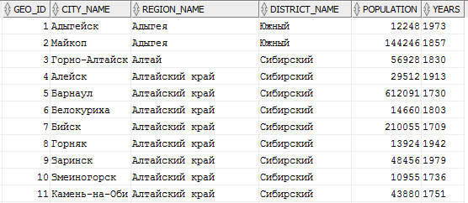



## Table products

Will add more later

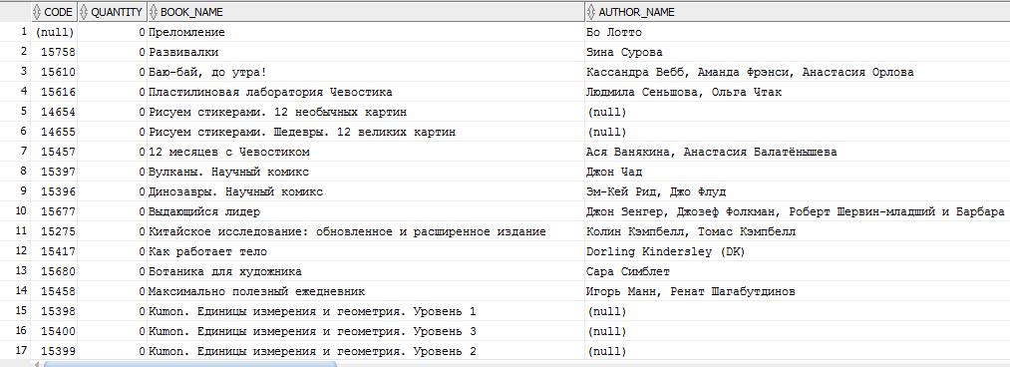



## Tables stores

Multiple sources.

### Source 1

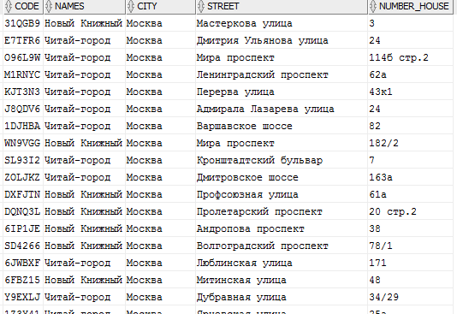



### Source 2

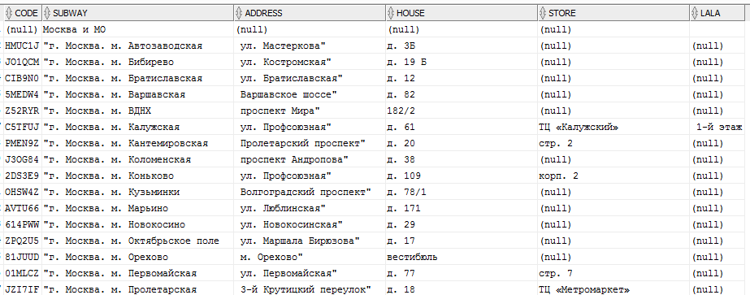



## Table payments

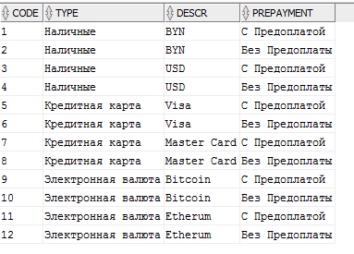

## Table employees

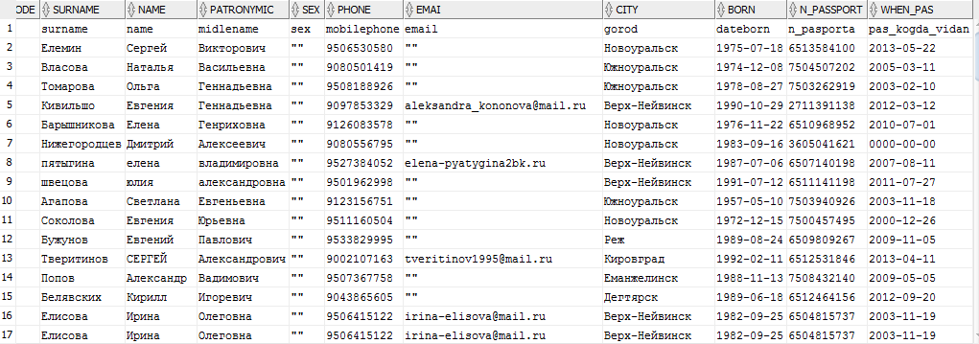



## Table customers

### Source 1

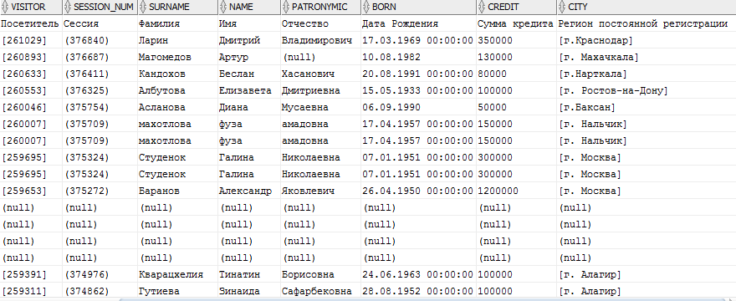



### Source 2

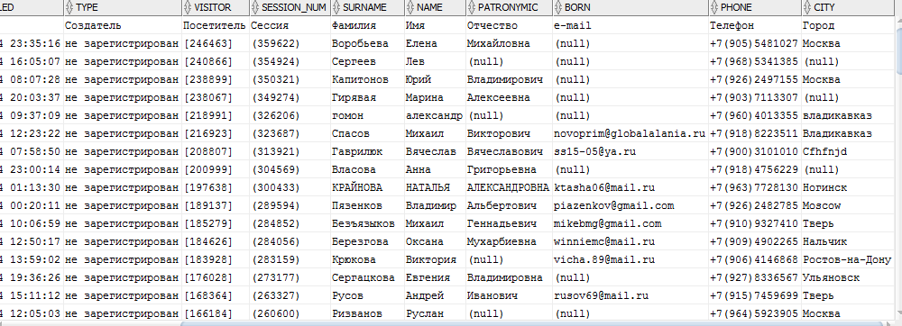



### Source 3

